**DECIMAL TO BINARY CONVERSION**  
  
  
**EXP NO: 25**  
  
  
  
  
  
**AIM:**To write a C program to implement decimal  
to binary conversion.  
  
  
  
  
  
  
  
  
**ALGORITHM:**  
  
  
1)       
Check if your number is odd or even.  
  
  
2)       
If it's even, write 0 (proceeding  
backwards, adding binary digits to the left of the result).  
  
  
3)       
Otherwise, if it's odd, write 1 (in the  
same way).  
  
  
4)      Divide  
your number by 2 (dropping any fraction) and go back to step 1. Repeat until  
your original number is 0.  
  
  
 

**PROGRAM:**  
#include<stdio.h>

#include<stdlib.h>

int main(){

int a[10],n,i;

printf("Enter the number to be converted:");

scanf("%d",&n);

for(i=0;n>0;i++)

{

a[i]=n%2;

n=n/2;

}

printf("Binary numbers=");

for(i=i-1;i>=0;i--){

printf("%d",a[i]);

}

}  
  
**INPUT & OUTPUT:**

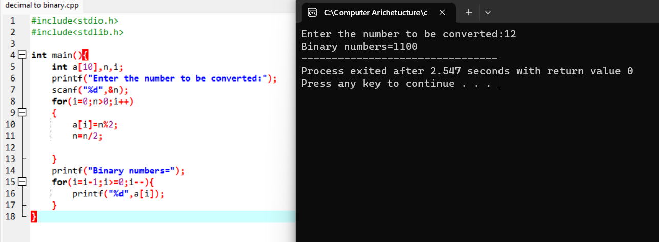

**RESULT:**Thus the program was executed successfully using DevC++.